Tenant Portal - New User Setup
- Tenants may navigate to https://apps.auburnhousingauth.org/ and select the Register option.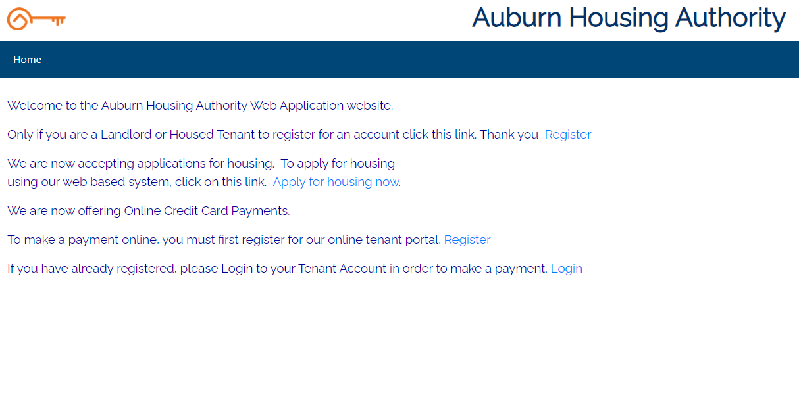
- Tenants will begin the new user registration process by entering the tenant information below selecting Tenant for the Registrant Type. The system uses the SSN to match the tenant to their SACS Record automatically. 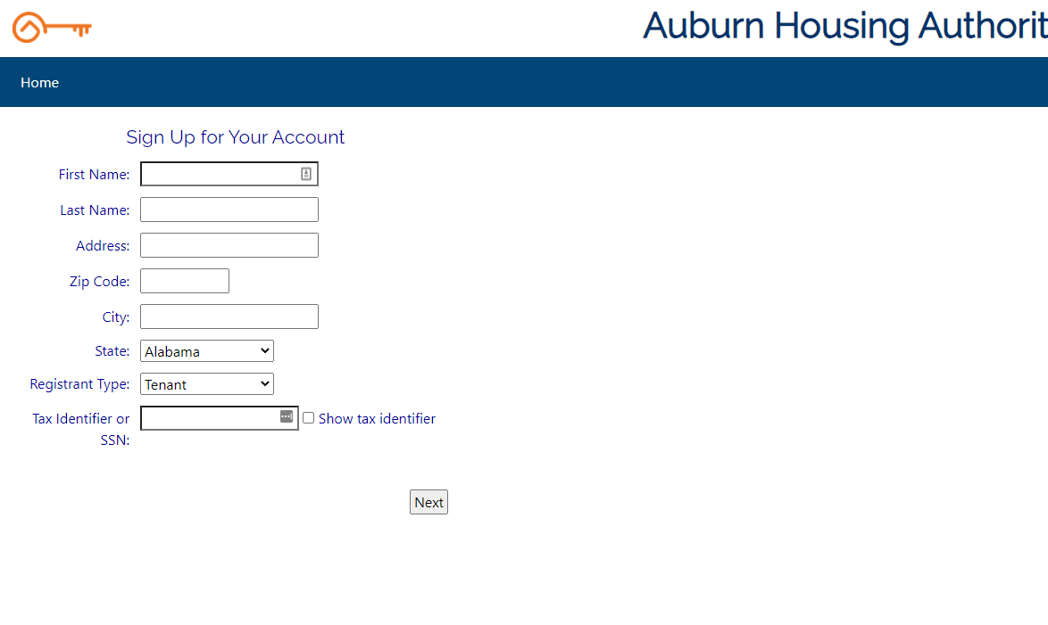
- Tenants will select Next and be prompted to create User Name, Password, Email, Security Question & Answer. 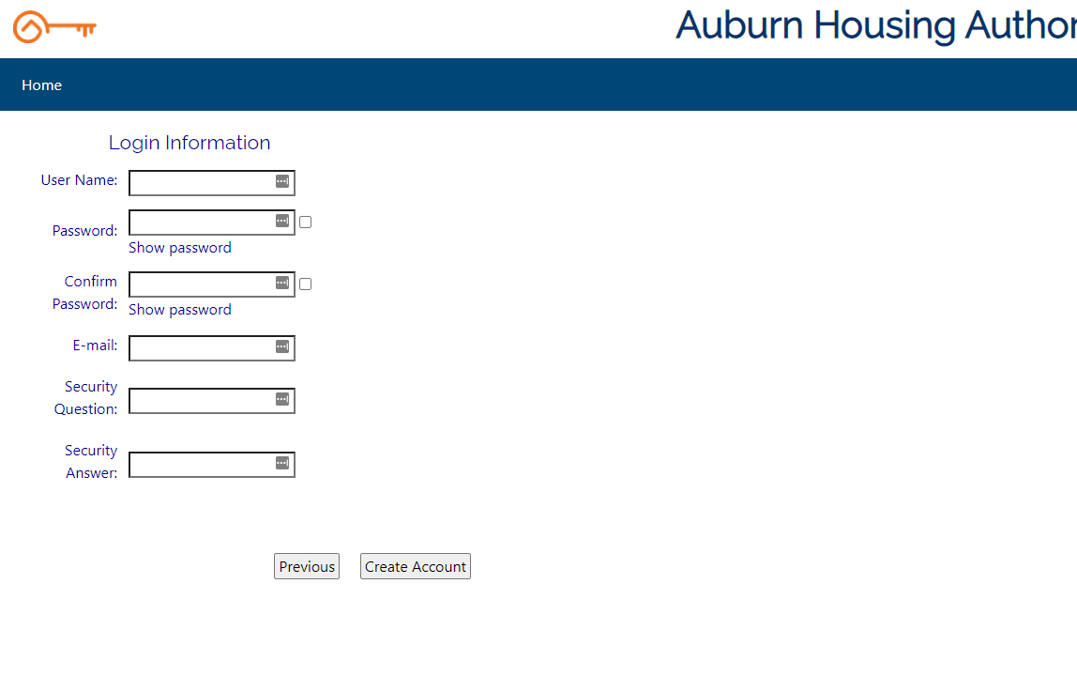
- Tenant will be logged into Conventional Tenant home page, they will need to remember the credentials used to create their new account. 

